Excel is a commercial spreadsheet application produced and distributed by Microsoft for Microsoft Windows and Mac OS. It features the ability to perform basic calculations, use graphing tools, create pivot tables and create macros. Excel has the same basic features as all spreadsheet applications, which use a collection of cells arranged into rows and columns to organize and manipulate data. They can also display data as charts, histograms, and line graphs. Excel permits users to arrange data so as to view various factors from different perspectives. Visual Basic is used for applications in Excel, allowing users to create a variety of complex numerical methods.
Microsoft Excel
Excel is typically used to organize data and perform financial analysis. It is used across all business functions and at companies from small to large.
The main uses of Excel include:
- Data entry
- Data management
- Accounting
- Financial analysis
- Charting and graphing
- Programming
- Time management
- Task management
- Financial modeling
- Customer relationship management (CRM)
Excel Interface
Opening Excel reveals a spreadsheet with these key elements:
- Ribbon: The top toolbar with tabs like Home, Insert and Data. Each tab contains tools, such as formatting options or chart creation.

- Quick Access Toolbar: A small bar above the ribbon with shortcuts like Save or Undo.

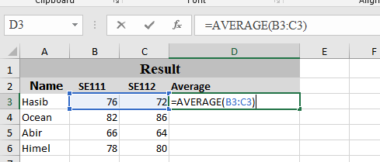
- Formula Bar: Above the worksheet, it displays the selected cell’s content, such as text or formulas.
- Worksheet: The grid of rows (numbered) and columns (lettered). Cells, like A1 or B2, are where we input data.
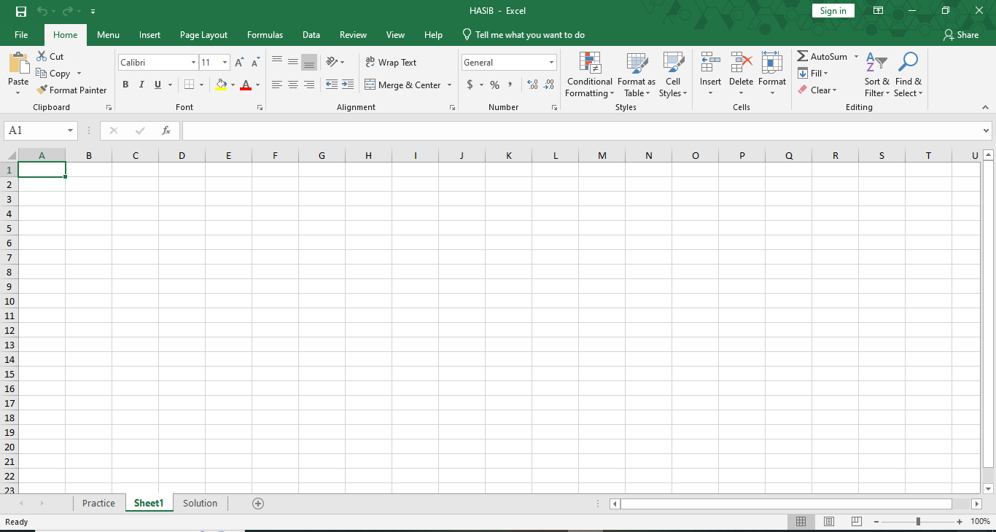
Sheet Tab
Column Letter in Column Header
Add New Sheet
Row Number in Row Header
Active Cell

Status Bar: At the bottom, it shows quick calculations (e.g., sum or average) for selected cells.
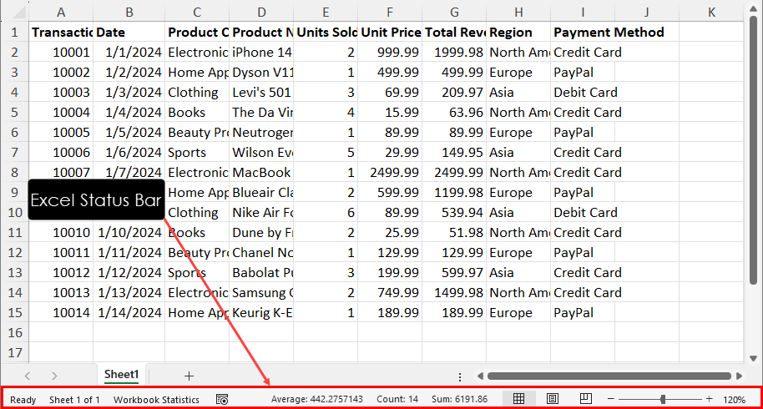

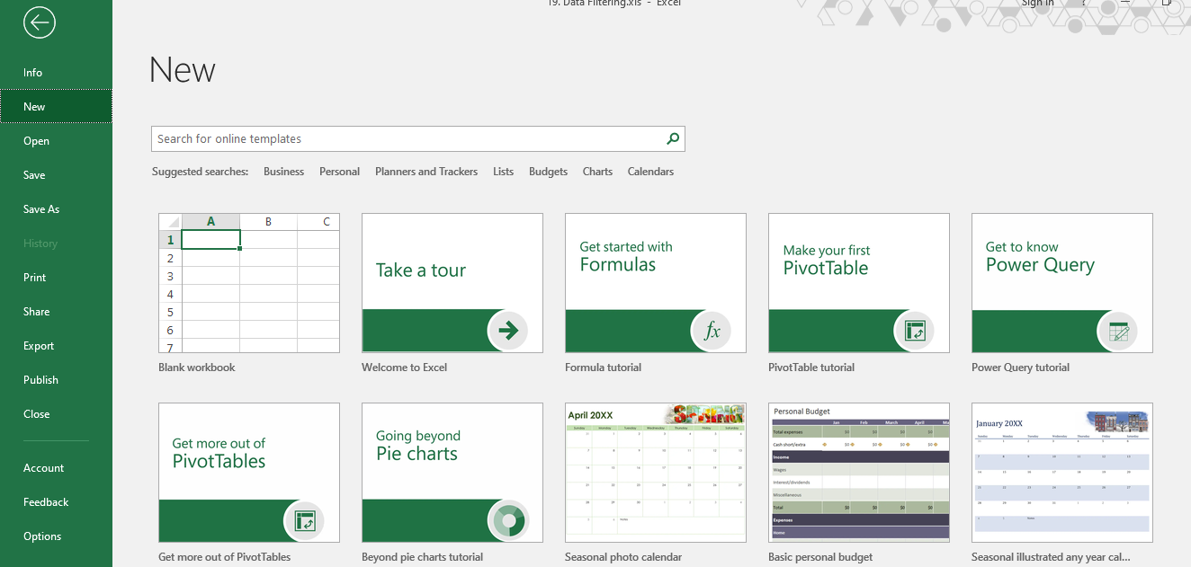
The File tab in Microsoft Excel provides access to commands used to manage workbooks. It allows users to create new files, open existing workbooks, save or save files with a new name, and print worksheets. The File tools also include options to share files, export data, protect workbooks, and adjust Excel settings. These tools help users control file-related tasks efficiently and manage their Excel documents properly.
1.File
File Tools:
Clicking the File tab opens the Backstage View for file management:
- Info: Protect Workbook, Check for Issues, Manage Workbook versions.
- New: Create a new blank workbook or use templates.
- Open: Access recent files or browse for others.
- Save & Save As: Save your work in various formats like .xlsx, .csv, .pdf.
- Print: Preview and print your spreadsheets.
- Share: Share via OneDrive, email, or present online.
- Export: Create PDF/XPS or change file types.
- Account & Options: Manage settings and account info.
2.Home
The Home tab in Microsoft Excel contains the most frequently used tools for creating, editing, and formatting worksheets. It provides options to change font type, size, color, and cell styles to improve the appearance of data. Users can align text, merge cells, wrap text, and adjust row height and column width for better layout. The Home tools also allow users to format numbers as currency, percentage, date, or decimal values. In addition, this tab includes tools for inserting, deleting, and clearing cells, sorting and filtering data, applying conditional formatting, and performing basic editing tasks such as copy, paste, and find and replace. These features help users organize data clearly and work more efficiently in Excel.

Key Components of the Excel Home Tab:
Clipboard: For Cut, Copy, Paste.
Font: Change font type, size, color, bold, italicize.
Alignment: Text alignment, merge cells, text orientation.
Number: Format cells as currency, percentage, dates, etc.
Styles: Conditional formatting, cell styles, format as table.
Cells: Insert/delete rows/columns, format cells.
Editing: AutoSum, Fill, Clear, Sort & Filter, Find & Select.
Excel Formulas
One of Excel’s strengths lies in its ability to perform quick and accurate calculations using formulas and functions. Even in basic spreadsheets, we might use:
Formula | Purpose | Definition
SUM | Adds a range of numbers | Totals values in a specified range
AVERAGE | Calculates the mean of a range | Finds the average of values in a range
MAX | Finds the largest value in a range | Returns the highest value in a specified range
MIN | Finds the smallest value in a range | Returns the lowest value in a specified range
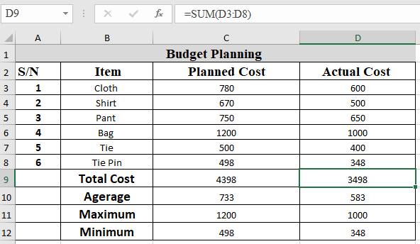

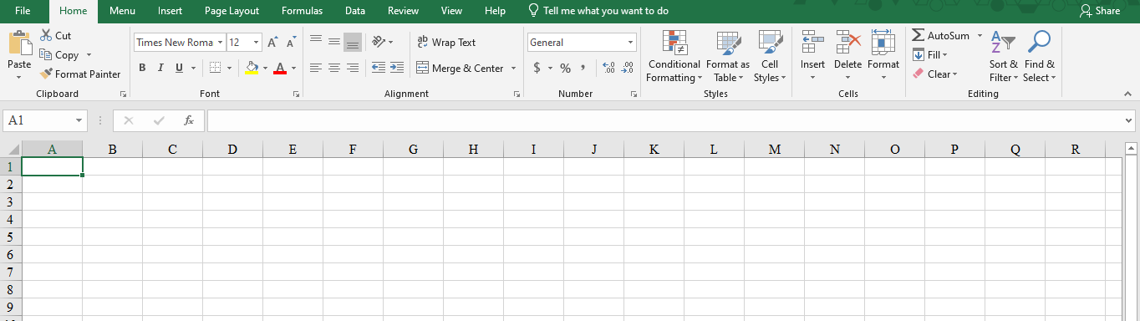
Clipboard
Font
Alignment
Number
Style
Cell
Editing
3.Insert
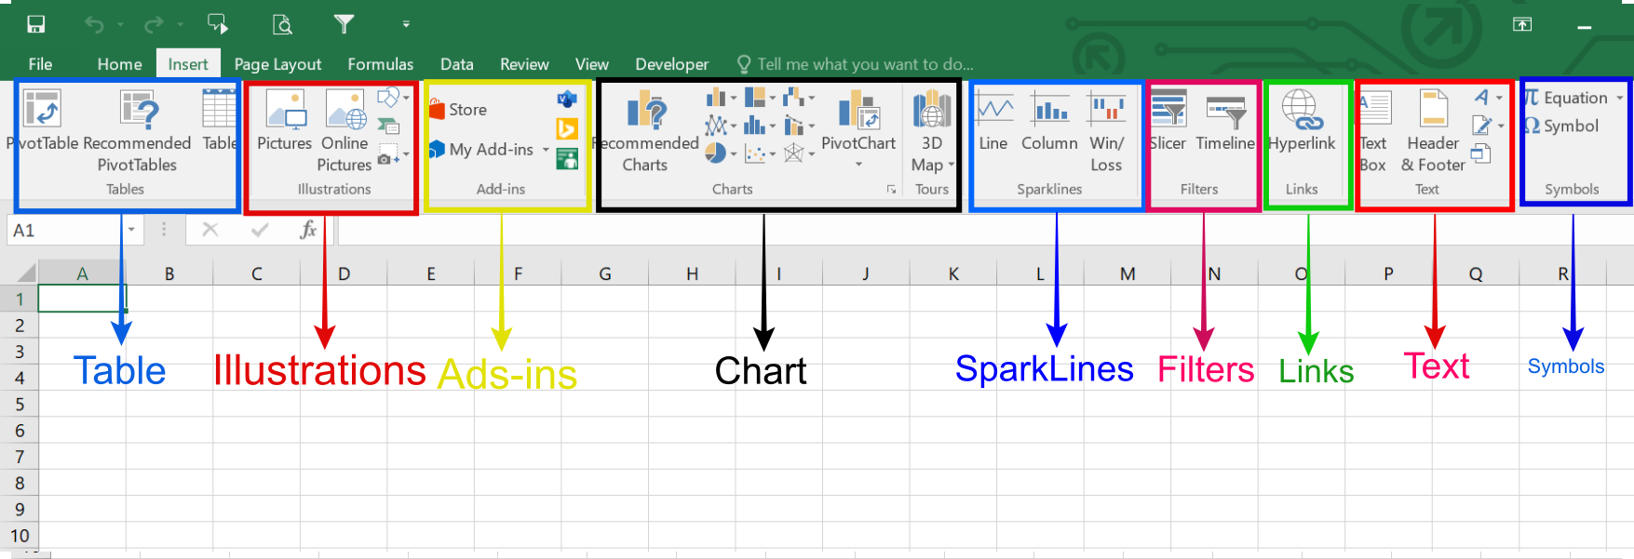
The Insert tab in Microsoft Excel is used to add various objects and elements into a worksheet to enhance data presentation and analysis. It allows users to insert tables, charts, illustrations, links, text, and symbols that help visualize information more effectively. By using the tools available in the Insert tab, users can transform raw data into meaningful and interactive content. This tab plays an important role in making worksheets more organized, informative, and visually appealing. In the following section, key Insert tools and groups are discussed with the help of images.

The image displays the "Insert" tab ribbon in Microsoft Excel, highlighting various tools for adding different elements to a spreadsheet.
- Table: Create and format tables to organize data.
- Illustrations: Insert pictures, shapes, icons, and 3D models.
- Add-ins: Access the Office Store to find and manage additional functionalities.
- Chart: Visualize data using a variety of chart types, including recommended options and PivotCharts.
- SparkLines: Add small charts within a single cell to show data trends.
- Filters: Utilize Slicers and Timelines for interactive data filtering.
- Links: Insert hyperlinks to connect to other locations or files.
- Text: Add text boxes, headers, and footers.
- Symbols: Insert mathematical equations or special symbols.

4.Page Layout
The Page Layout tab in Microsoft Excel is used to control the appearance and layout of a worksheet, especially for printing purposes. It allows users to adjust page settings such as margins, orientation, paper size, and scaling to ensure that data is printed clearly and professionally. This tab also provides tools for applying themes, changing page background, and organizing worksheet elements properly. By using the Page Layout tools, users can improve the overall structure and visual consistency of a worksheet. In the following section, the key Page Layout tools and groups are explained with the help of images.
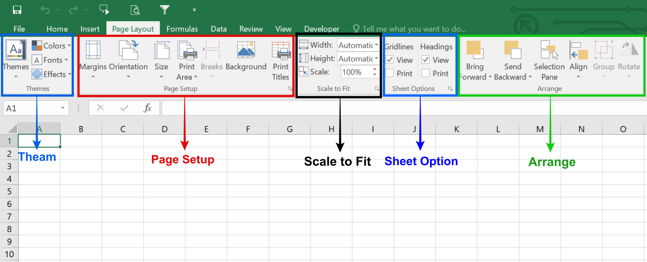
Themes
Page Setup
Scale to Fit
Sheet Option
Arrange
Key Groups in the Page Layout Tab:
- Themes: Quickly change the overall look with coordinated colors, fonts, and effects.
- Page Setup:
- Margins: Adjust space around the content.
- Orientation: Switch between Portrait (tall) and Landscape (wide).
- Size: Select paper size (e.g., Letter, A4).
- Print Area: Define which cells get printed.
- Breaks: Insert or remove manual page breaks.
- Background: Add a background image to the sheet.
- Print Titles: Set rows or columns to repeat on every printed page.
- Scale to Fit: Resize content to fit a specific number of pages (e.g., "Fit to 1 page wide by 2 pages tall").
- Sheet Options: Control visibility of gridlines and headings (A, B, C; 1, 2, 3) on printouts.
- Arrange: Tools for positioning and formatting shapes, pictures, and other objects.
5.Formulas
The Formulas tab in Microsoft Excel is used to perform calculations and manage formulas efficiently within a worksheet. It provides access to a wide range of built-in functions such as mathematical, logical, financial, and statistical functions. This tab also includes tools for inserting functions, defining named ranges, checking formula errors, and auditing calculations. By using the Formulas tab, users can analyze data accurately and automate complex calculations. In the following section, the key Formula tools and groups are discussed with the help of images.
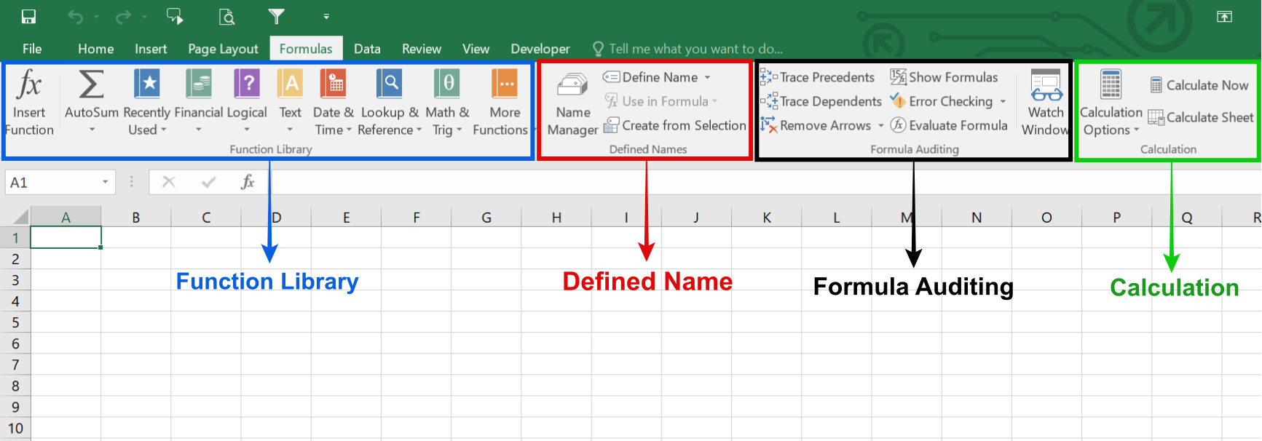
The image displays the Formulas tab in Microsoft Excel, highlighting the different groups of tools available for working with functions and calculations.
- Function Library: Contains a wide variety of built-in functions (e.g., Financial, Logical, Text, Date & Time, Lookup & Reference, Math & Trig) to help process data.
- Defined Names: Allows users to define, manage, and use names for cells or ranges within formulas.
- Formula Auditing: Provides tools like Trace Precedents, Trace Dependents, Error Checking, and Evaluate Formula to ensure formulas are correct.
- Calculation: Controls when and how calculations are performed in the workbook, with options like Calculate Now and Calculate Sheet.
6.Data
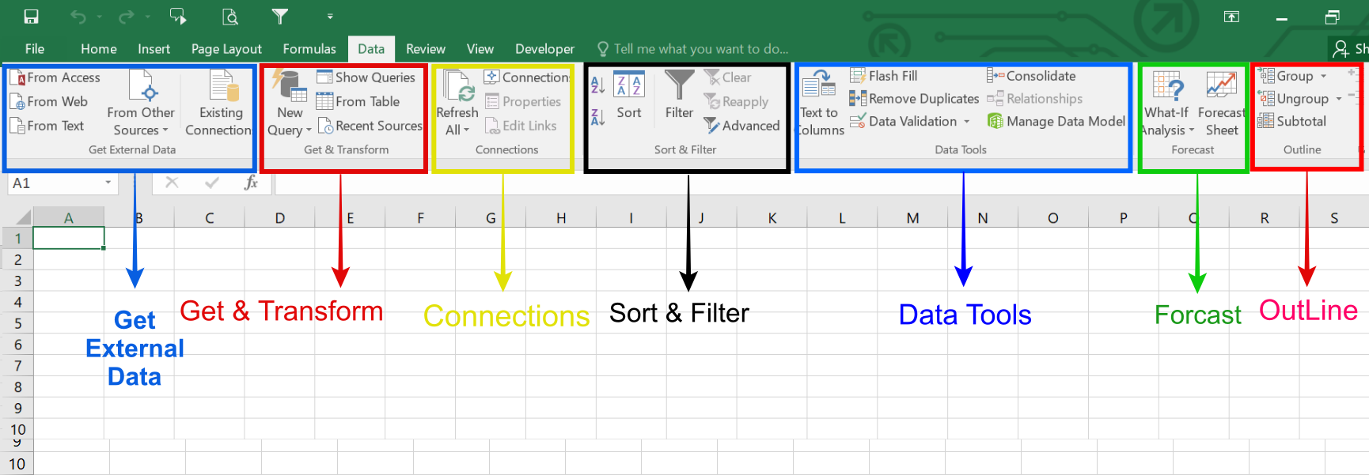
The Data tab in Microsoft Excel is used to manage, organize, and analyze large amounts of data effectively. It provides tools for importing data from different sources, sorting and filtering information, and cleaning data for accuracy. This tab also includes features for data validation, removing duplicates, and converting text into columns. In addition, the Data tab offers tools for analyzing data such as what-if analysis, forecasting, and grouping data. By using the Data tools, users can ensure data consistency and perform accurate analysis. In the following section, the key Data tools and groups are explained with the help of images.
- Get External Data / Get & Transform: This group is used to import data into Excel from external sources such as text files, databases, websites, or other Excel files. It also allows users to clean, transform, and organize imported data before using it in the worksheet.
- Connections: The Connections group manages links between Excel and external data sources. It allows users to refresh data, view existing connections, and control how external data is updated in the workbook.
- Sort & Filter: This group is used to arrange and analyze data easily. Users can sort data in ascending or descending order and apply filters to display only specific information based on selected criteria.
- Data Tools: The Data Tools group helps in cleaning and managing data. It includes features like Data Validation, Remove Duplicates, Text to Columns, and Flash Fill, which improve data accuracy and organization.
- Forecast: This group is used for predicting future trends based on existing data. It provides tools such as What-If Analysis and Forecast Sheet to help analyze possible outcomes.
- Outline: The Outline group helps organize large datasets by grouping and summarizing data. Users can collapse or expand rows and columns to view data in a structured and simplified way.

7.Review
The Review tab in Microsoft Excel provides tools for checking, reviewing, and protecting worksheets. It allows users to check spelling, add comments or notes, track changes, and protect workbooks and worksheets. These tools help improve accuracy, collaboration, and data security.
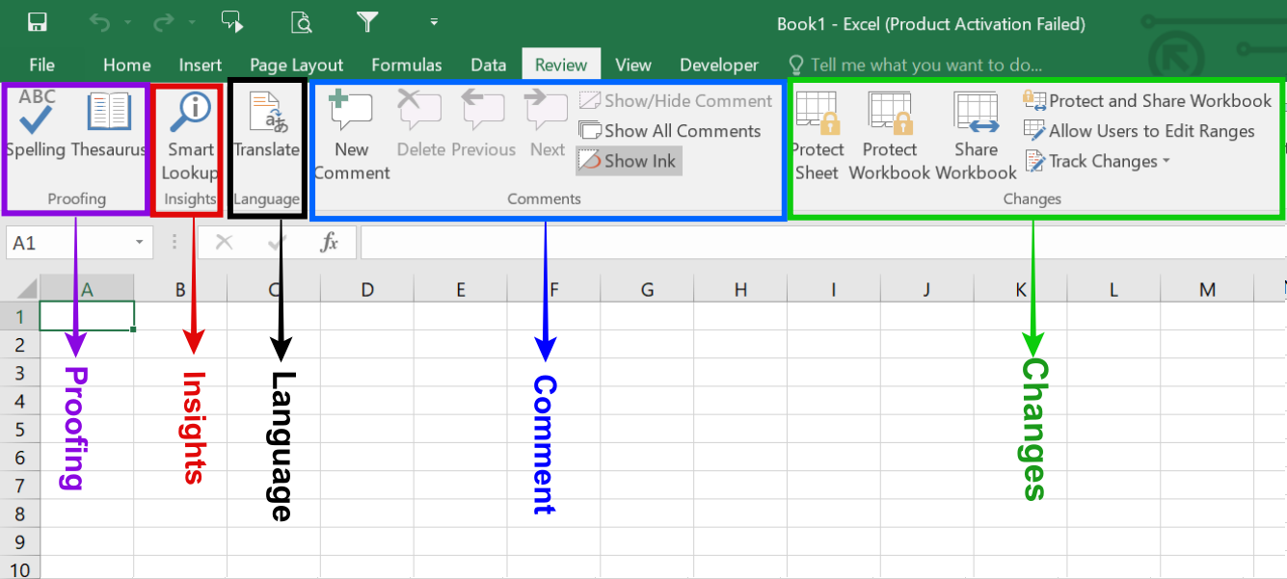
1. Proofing: The Proofing group is used to check spelling and grammar in worksheet content. It also provides tools like Thesaurus to find synonyms and improve text accuracy.
2. Insights: The Insights tool helps users analyze data automatically. It provides quick suggestions, patterns, and summaries from the selected data to support better decision-making.
3. Language: The Language group is used to translate selected text into different languages. It also allows users to set the proofing language for spell checking.
4. Comments :The Comments group allows users to add, edit, delete, and navigate comments in a worksheet. It is mainly used for collaboration, feedback, and explanations without changing the actual data.
5. Changes: The Changes group is used to protect worksheets or workbooks and manage editing permissions. It also includes tools like Track Changes and Share Workbook to monitor and control modifications made by different users.
8.View
The View tab in Microsoft Excel is used to control how a worksheet is displayed on the screen. It allows users to switch between different workbook views, zoom in or out, show or hide gridlines and headings, freeze panes, and manage multiple windows. These tools help users view and work with data more comfortably and efficiently.
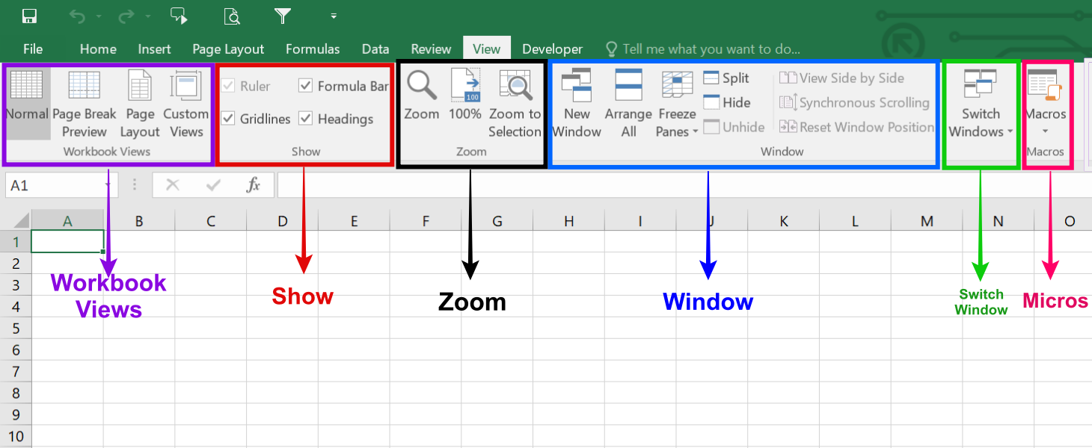
The marked items in the Microsoft Excel View tab image have the following functions:
Workbook Views: This group contains commands to change the overall display of the workbook, such as Normal, Page Break Preview, and Page Layout views.
Show: This group allows users to show or hide specific interface elements like gridlines, the formula bar, and column/row headings.
Zoom: This feature provides options to quickly zoom in, zoom out, or zoom to a specific selection on the worksheet.
Window: This group offers tools for managing open workbook windows, including opening a new window, arranging all open windows, splitting the view, or switching between different windows.
Macros: This functionality is used to record, view, or manage automated tasks (macros) within Excel.
9.Conclusion
Microsoft Excel is a powerful and versatile application that plays a vital role in data management and analysis. With its wide range of features such as formulas, functions, charts, tables, and data tools, Excel enables users to organize information, perform accurate calculations, and present data in a clear and meaningful way. Whether used for academic work, business tasks, or personal projects, Microsoft Excel improves efficiency, accuracy, and productivity, making it an essential tool in today’s digital world.

